
ALLERGEN SHEET

Menu Item | 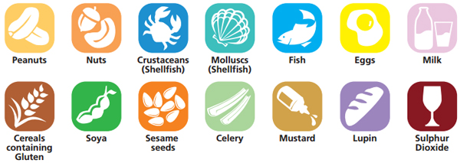
Southern fried chicken,fries,salad | x | x
Spicy bean steak |  | x
Spicy chicken and siracha wrap and tortilla crisp | x | x |  | x |  |  | x |  |  |  |  |  |  | x
Chicken and spinach cuyrry with rice | x | x |  |  |  |  |  |  | x |  |  | x
Beetroot falafel,Bombay potatoes | x | x |  |  |  |  |  |  | x |  |  | x
Snack box and vegetable egg fried rice |  | x |  | x |  |  | x |  | x |  |  |  | x | x
Mexican vegi mince buritto |  | x |  |  |  |  | x |  | x |  |  |  | x
Spicy fish,wedges sirracha |  | x | x |  | x |  | x
Fishless fish steak |  | x | xx | x | x |  | x
Loaded wedges,donner meat and garlic sauce and wraps |  | x |  | x |  |  | x |  | x |  |  |  | x
Roated veg curry,rice | x | x |  |  |  |  | x |  | x |  |  |  | x
Lasagna,and garlic slices |  | x |  | x |  |  | x |  |  |  |  |  | x
Roasted veg lasagna |  | x |  | x |  |  | x |  |  |  |  |  | x
Chicken fajitas and corn on the cob |  | x |  |  |  |  | x |  |  |  |  |  | x | x
Sweet potato wrap,seasoned potoes |  | x |  | x |  |  | x |  |  |  |  |  | x
Donner meat kebab,wedges | x | x |  | x |  |  | x |  |  |  |  |  | x
Roasted veg donner,wedges |  | x |  | x |  |  | x |  |  |  |  |  | x
Margherita pizza,chips,beans | x | x |  | x |  |  | x |  |  |  |  |  | x
Meat panini | x | x |  |  |  |  | x |  | x |  |  |  | x
Pizza style panini |  | x |  | x
donut |  | x |  | x |  |  | x |  |  |  |  | x | x
Chocolate orange ,sweet cake |  | x |  | x |  |  | X
Chocolate flapjack |  | x |  |  |  |  | x |  |  |  |  |  | x
Muffins |  | x |  | x |  |  | x |  |  |  |  | x | x
Ice cream |  |  |  |  |  |  | x
waffles |  | x |  | x |  |  | x |  |  |  |  |  | x
brownie |  | x |  | x |  |  | x |  |  |  |  |  | x
Crispy buns |  |  |  |  |  |  | x |  |  |  |  |  | x
Chocolate and beetroot cake |  | xx |  | x |  |  | x |  |  |  |  |  | x
Tuna jacket potatoes |  |  |  | x | x |  | x
Baked beans jacket potoes |  |  |  |  |  |  | x
Cheese pots
Bagels and butter |  | x |  | x |  |  | x |  |  |  |  | xx
toast |  | x |  |  |  |  | x
Cajuned spiced arabatia whole meal pasta and garlic slice |  | x |  | x |  |  | x
Pineapple cake |  | x |  | x |  |  | x

